**Angular 4 Document**

1. **How to Install Angular4 in windows?**

Angular 4 is a JavaScript framework for building web applications and apps in JavaScript, CSS, HTML and TypeScript, which is superset of JavaScript. Angular 4 introduces angular-cli with this we can create angular 4 project folder structure very easily.

Before Installing Angular4, need to verify node.js and npm are installed in our system. If not installed we need to install first.

1. **Nodejs and NPM**:

Download from this link  
 <https://nodejs.org/en/download/>

Once download and installed this software, check with node.js and npm version.

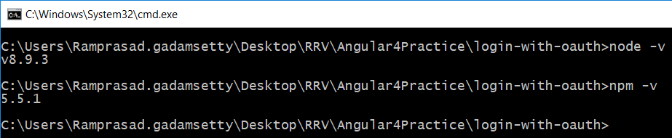

Installed node is latest but for angular4, should have at least v6 version and npm v3.10.10

If Already installed npm and need to update the version, use this command

**npm -g update** // run this command in administrator mode.

1. angular-cli for Angular4

**npm install -g @angular/cli**

1. Create project folder structure using below command

**ng new project-name**

1. Move to inside project and run the below command

**ng serve**

Open application in browser using <http://localhost:4200(4200> is default port for angular4)

We can change port number using below command

**ng serve –port 4500**

1. To create new component run below command

**ng generate component Login** or in short cut **ng g c Login**

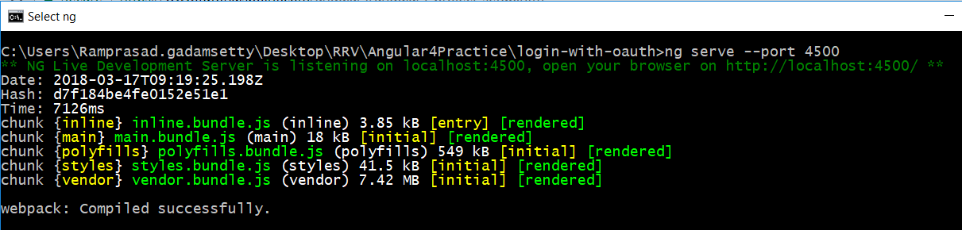

When we use this command, we need to open browser explicitly. If application need to open in browser implicitly we need to run below command

**ng serve –open**